Software Requirements Specification
for
2d shooter platformer game
Version <1.0>

Prepared by
Group Name: Crypto
Danial Adnan Ansari | SE-46095
Muhammad Usama | SE -46131
Imran Khan | SE-46108

Instructor: | Muhammad Faisal
Lab Instructor: | Ramsha Mashood
Contents
Revisions iii
1 Introduction 1
1.1 Document Purpose 1
1.2 Product Scope 1
1.3 Intended Audience and Document Overview 1
1.4 Definitions, Acronyms and Abbreviations 1
1.5 Document Conventions 1
1.6 References and Acknowledgments 2
2 Overall Description 3
2.1 Product Perspective 3
2.2 Product Functionality 3
2.3 Users and Characteristics 3
2.4 Operating Environment 3
2.5 Design and Implementation Constraints 4
2.6 User Documentation 4
2.7 Assumptions and Dependencies 4
3 Specific Requirements 5
3.1 External Interface Requirements 5
3.2 Functional Requirements 6
3.3 Behaviour Requirements 6
4 Other Non-functional Requirements 7
4.1 Performance Requirements 7
4.2 Safety and Security Requirements 7
4.3 Software Quality Attributes 7
5 Other Requirements 8
Appendix A – Data Dictionary 9

Introduction

Document Purpose
The purpose of this document is to get familiar with the project scope and the requirements covered by the project. The project is based on a game, which is a simple 2d arcade game. This document will cover the basic requirements and all the functional non functional requirements to get a good understanding of the project. So that if any changes are to be made or altered, this document would come handful.

Product Scope
This game is a 2d game, based on a single player shooter arcade genre. It has three different levels with varying level of difficulties. So that every user can play it .The goal was to create a game which is a base for the basic understanding of designing graphical games. It was intended that this project would be the first step.

This game would allow any beginners in the field of game development to use this as a first step, or example. So they can get to other further advanced game development.

Intended Audience and Document Overview

This document is intended for our teacher and the users for whom we have developed this game, and also those people who are interested in game development and are beginners.
This document is in a specific format and contains sectional information, The specific requirement sections is to be read by the users who want to use this game, and the overall description is for the developers.

Definitions, Acronyms and Abbreviations
Audience – people who are going to use this project.

Document Conventions
This document follows the IEEE formatting, so you need to use the arial font throughout the document, and also italic font for any comments. Document text should be single spaced and maintain the 1” margins.

References and Acknowledgments

Overall Description

Product Perspective

The project built by us is a game, which is a new self contained product. It has been developed on the general ideology of games of the arcade games, which were built in the previous decades. Thus still they are in market , for people who like them, and has its own importance even in the presence of high quality 3d games, they are used by millions of users.

USER

Enemy thread

Levels thread

Main thread

.NET Framework

Product Functionality

- Player which you can move with keys
- Enemy
- Levels
- Health bar
- Blocks
- Textures
- Shoot

start

Shoot everything that moves

Advance to next level

Users and Characteristics

The users of our project will be following
- Normal game users – they are not concerned about the development , they only want results.
- Developers – they are more concerned about the code.the code should be optimised.
- Instructor.

Normal users are different from developers.. and both these type of users are important. They are not comparable to the instructor, because instructor is not going to play the game or enjoy it. He/She is going to give us remarks. The most important type of users are the normal users and the teacher..

Operating Environment

The following requirements need to be fulfilled for the environment.
- Windows 10
- . NET Framework 4.5
- Visual Studio
- 4 gb ram for running visual studio(Not compulsory for game) but for only development purpose.

Design and Implementation Constraints

The following are the constraints.
- The system should have enough ram for development.
- The system should have enough disk space.
- The system should have stable version of visual studio
- The system should have atleast directx11
- The system should have atleast windows 7.

User Documentation
The normal users are required to take help from the user manual for installing,if they face any difficulty and the developers are required to read documentation of the game for any development queries.

Assumptions and Dependencies

The system should have the following components.
- A single pc with windows 7,8 or 10
- . NET FRAMEWORK 4.5
- Visual studio 13 or higher
- Enough ram
- The system has atleast Pentium 4 processor.

Specific Requirements

External Interface Requirements

User Interfaces

Interface #1(Level 1):
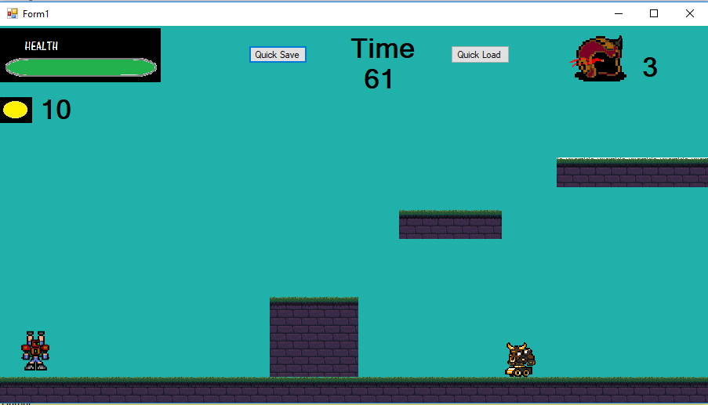

In the above interface we have the first level of our game. This interface just like every other level has a lifebar,avalaible energy,tries left and a Timer.At this level you have a very easy enemy to defeat who simply charges at you a moderate speed,
To do
defeat the enemy by shooting at him 3 times and complete the level by climbing the 2 flying platforms and exiting the screen from the right .
Interface #2(Level 2):
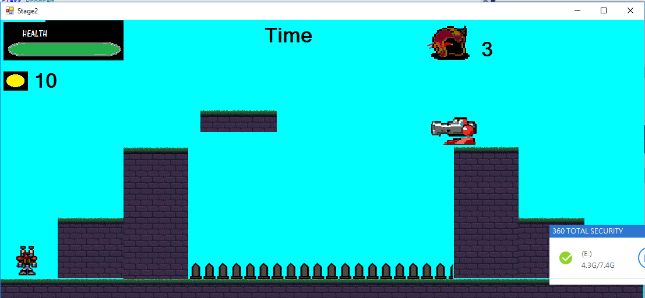

In this interface we have our 2nd level.At this the diffuiculty increases with the addition of a shooting enemy and tricky platform jumping mixed with some deadly spikes if you mess up.
To Do:
At this level jump your way up the stairs for a stand off with the shooting enemy,dodge his bullets by jumping and kill him by shooting 3 times at hin.After he is defeated the flying platform will begain to move left and right allowing you cross the deadly spikes, cross the pit carefully and after simply climb down the stairs and exit through the right side to complete the level.

3rd Interface:Boss Level
At this level all you have in your way is the big bad boss and nothing else.The boss uses 3 distinct attack randomly which you have to dodge.
To do:
Survive all the deadly attacks of the boss and manage to hit him 10 times in order to defeat them and win the game.

Hardware Interfaces

We just need our keyboard hardware interface to communicate with the game. As it only requires keyboard keys to move the character. Apart from that, you need a mouse for other options.
In visual studio , these interfaces are already handled by built in Libraries of .NET framework of System.

Software Interfaces

The software interfaces you need to communicate with will be provided by Visual studio, as the game is built on it.
Further more, Windows 7,8 or 10 will be the platform you would be working on.
Apart from that, you need the . NET framework, for running it on the visual studio.

Communications Interfaces

The communicate in game through threads, because every separate entity is enclosed in threads, so communication between different entities is handled through threads.

Functional Requirements
- Controllable Main Character:
In order for the game to function properly it is atmost important that the user can control the character with ease and can play the game properly

- Envoirment Interaction:
In order for the game to have some thirll it is important that he is interacting with other components and obstacles around him properly such as taking damage from enemies and standing on flying platforms

- Shooting Element
Our game is literally called 2d platformer shooter game to therefore it is utmost important for the character to be able to shoot his enemies.

- Save/Load Feature
This feature is important so that the user can save his progress and continue some other time.

Behaviour Requirements

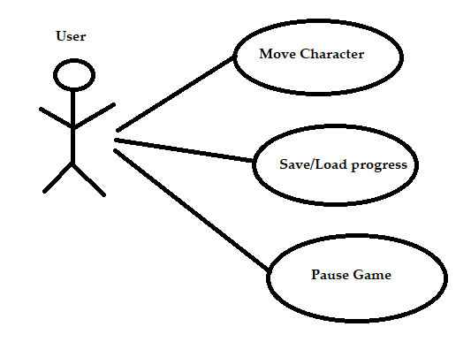
Use Case View

Other Non-functional Requirements

Performance Requirements
- In order to make the game more challening an short we have set a 60 second timer for every level.Sicen each level eats up quite some ram we need to make sure to end the level quick.
- Enemies Moves might seem a little to fast but they are done so such that if your ram usage is high and when the game starts to slow down atleast the game will still be playable .
- All un necessary threads after use are immediatly terminated in order to reduce the load on the game.
- Any heavey imagery cannot be used since that slows down the game as well as cause the artwork in the game to go bad.
- Try catch was a necessay in this project since even the usage of multiple threads gives an error in this however with the use of try catch we were able to keep it alive

Safety and Security Requirements
- Do not mess with the images in the project resources since they can cause the game to stop working.
- Try to minimize the use of constand shooting since that may cause the game to crash

Appendix A – Data Dictionary
Sprites:
Main Characer
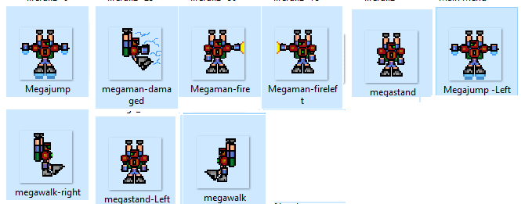

Enemies:
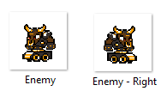

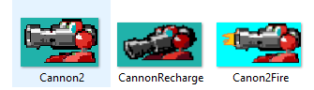

Boss:
